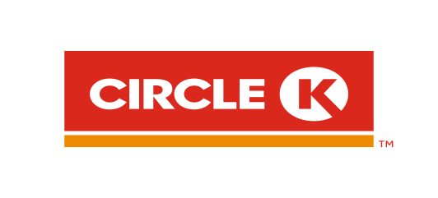
CIRCLE K MANAGEMENT TRAINEE PROGRAM - 2018
In the framework of personnel training and development of Circle K Viet Nam, the Management Trainee program is developed to recruit and build outstanding fresh graduates to become the future leaders of Circle K Vietnam.
We look for talent candidates with the following qualifications:
- Vietnamese nationality with Bachelor or Master degree
- Graduate in 2017 or 2018 with GPA from 7/10 or equivalent
- Excellent interpersonal skill, strong teamwork & potential leadership
- Integrity, passion & can-do attitude
- Proficient in English and Microsoft Office.
As Management Trainee at Circle K Vietnam - you will have the opportunities to be trained rotation among different departments, such as: Operations, Merchandising, Marketing, Finance, Human Resources,… then you will be given priority for selecting department that you expect to continue working and developing.
Please send your resume in English and transcription via email: mt.hn@circlek.com.vn or click here to apply before September 30, 2018.
Contact information:
- Human Resources Department – Circle K Vietnam, Hanoi Branch.
- Tel: (+844) 2268.2288
- Address: No 8 Phan Van Truong str., Dich Vong Ward, Cau Giay Dist., Hanoi.
- Email: mt.hn@circlek.com.vn
- Website: www.circlek.com.vn

